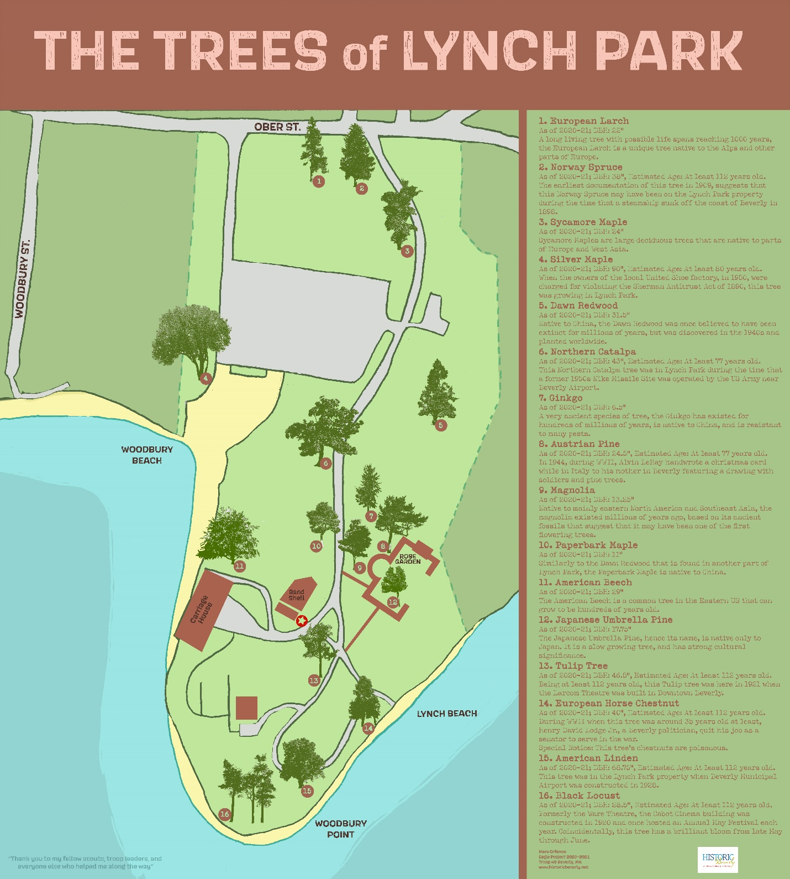
Support great projects like this with a gift to Historic Beverly!
Your donation helps to preserve Beverly’s cultural heritage.
Become a Member
Donate
Upcoming Events

